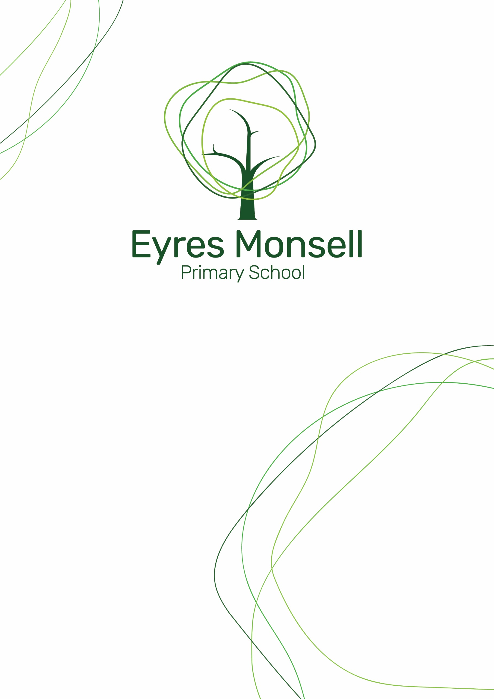

Accessibility Plan
2026 - 2028
Approved by  Date | FGB  March 2026
Review date | March 2027
Signed
(Chair of Governors)

Contents
1. Vision statement
2. Aims
3. Legislation and guidance
4. Safeguarding
5. Action Plan
6. Monitoring arrangements
7. Links with other policies

Vision Statement
Purpose of the Plan
The purpose of this plan is to show how Eyres Monsell Primary School intends, over time, to increase the accessibility of our school for disabled pupils. Eyres Monsell Primary School is committed to providing an environment that enables full curriculum access that values and includes all pupils, staff, parents and visitors regardless of their education, physical, sensory, social, spiritual, emotional and cultural needs.
The purpose of the plan is to:
- Increase the extent to which pupils with disabilities can participate in the curriculum
- Improve the physical environment of the school to enable pupils with disabilities to take better advantage of education, benefits, facilities and services provided.
- Improve the availability of accessible information to pupils with disabilities.
The plan will be made available online on the school website, and paper copies are available upon request.
Definition of Disability
According to the Equality Act 2010, a person has a disability if:
a) He or she has a physical or mental impairment.
b) The impairment has a substantial and long-term adverse effect on his or her ability to carry out normal day-to-day activities.
Aims
Our school aims to treat all its pupils fairly and with respect. This involves providing access and opportunities for all pupils without discrimination of any kind. Our school is also committed to ensuring staff are trained in equality issues with reference to the Equality Act 2010, including understanding disability issues. The school support any available partnerships to develop and implement the plan.
Legislation and guidance
This document meets the requirements of schedule 10 of the Equality Act 2010 and the Department for Education (DfE) guidance for schools on the Equality Act 2010.
The Equality Act 2010 defines an individual as disabled if they have a physical or mental impairment that has a ‘substantial’ and ‘long-term’ adverse effect on their ability to undertake normal day to day activities.
Under the Special Educational Needs and Disability (SEND) Code of Practice, ‘long-term’ is defined as ‘a year or more’ and ‘substantial’ is defined as ‘more than minor or trivial’. The definition includes sensory impairments, such as those affecting sight or hearing, and long-term health conditions such as asthma, diabetes, epilepsy and cancer.
Schools are required to make ‘reasonable adjustments’ for pupils with disabilities under the Equality Act 2010, to alleviate any substantial disadvantage that a pupil with disabilities faces in comparison with a pupil without disabilities. This can include, for example, the provision of an auxiliary aid or adjustments to premise.

Safeguarding
Eyres Monsell Primary School is an inclusive school and welcomes all pupils including those with SEND. We believe in providing every possible opportunity to enable our pupils to develop their full potential whilst promoting their self-esteem and valuing their individuality.
Some children have barriers to learning which means hey have special needs and require particular action by the school. Our dedicated SENCo and teachers take account of these requirements and make provision where necessary to support individuals or groups of children to enable them to participate effectively in curriculum and assessment activities.
Key issues for safeguarding children with disabilities include:
- Social isolation
- Reliance on others for personal care
- Impaired capacity to resist or report abusive behaviour
- Reduced access to someone to tell
- Vulnerable to bullying or intimidation
- More frequently away from home e.g. in hospital, respite care or residential living.

Our SENCO and teachers have attended appropriate training as part of their CPD; whole school safeguarding training, understand the vulnerability of SEND children and understand SEND children may be at higher risk of abuse or neglect. Eyres Monsell Primary School has a specific SEND policy. All our staff have access to this policy are key staff members are also aware of the Leicester Safeguarding Children Partnership Board Procedures.
Taking all of these requirements into account, this Accessibility Plan sets out the proposal for Governing Body of our school to increase access to education for disabled pupils in the three areas required by the planning duties.

Action Plan
This action plan sets out the aims of our accessibility plan in accordance with the Equality Act 2010.
Aim | Current good practice | Objectives | Actions to be taken | Person responsible | Date to complete actions by | Success criteria
Increase access to the curriculum for pupils with a disability | Our school offers a differentiated curriculum for all pupils.  We use resources tailored to the needs of pupils who require support to access the curriculum.  Curriculum resources include examples of people with disabilities.  Curriculum progress is tracked for all pupils, including those with a disability.  Targets are set effectively and are appropriate for pupils with additional needs.  The curriculum is reviewed to ensure it meets the needs of all pupils. | To share and understand the knowledge and expectations of teachers towards all children in their class. | Audit of teachers understanding of the expectations of class teacher on all children in their class- SEND focus | SENCo | Termly | Training on expectations  Staff feedback on audits and questionnaires
 |  | To develop the use of curriculum and assessment for children with SEND who are making small steps of progress. | Whole school training on key areas.  Partnerships with SEND Support Services.  New assessment scheme to be implemented | SENCo  Deputy Head  Curriculum Subject Leads | Termly | All children are able to be assessed in their steps of learning.  Staff feedback on audits.
 |  | To ensure P.E. continues to be accessible to all | Liaise with external agencies and sport coaches regarding specialist equipment or adaptations to teaching to include all pupils. | SENCo  PE Lead | On going | All children are able to access all areas of the curriculum and work towards attaining age related expectations.
 |  | To develop Sensory Integration intervention groups across school if necessary | Sensory circuits- SEN | SENCo  PE Lead | On going | SEND children accessing sensory integration intervention.
 |  | All staff aware of curricular needs of individual pupils regarding specialist equipment | Training in specialist equipment for all once highlighted as needed. IT installed as necessary and Staff/ Pupils to have regular training alongside SEND support Services e.g. Visional impairment team. | SENCo  Deputy Head | On going | All children are able to access all areas of the curriculum and work towards attaining age related expectations
 |  | All out of school activities planned to ensure, where reasonable, participation of all pupils. | Risk assessment in place to include all children in school trips an out of school activities where possible. | SLT  Phase Leaders  Class Teachers | On going | All children able to access all areas of the wider curriculum and attend alongside their peers in out of school activities.
 |  | Lunchtime withdrawal area or clubs: to support pupils with sensory difficulties or SEMH needs | Spaces to be planned and used at lunchtimes to support children with sensory difficulties or SEMH. | SENCO  SLT | On going | Children are able to have a variety of spaces and activities which they can access at lunchtime to support their needs.
Improve and maintain access to the physical environment | Entrances are accessible for disabled people.  The environment is adapted to the needs of pupils as required.  This includes:  - Lifts in the Reception, KS1 and KS2.  - Corridor width  - Disabled parking bays  - Two disabled toilets and one changing facility | To review the disabled toilet and current changing space to make sure it meets the needs of our pupils. | To improve the current lay out of the change facility and make it more accessible and fit for purpose. | Premises/Headteacher | When funding available. | Children and Adults are able to use the changing facility in a way which meets their needs and requirements.
Improve and maintain access to the physical environment |  | Improve internal access in school for visually impaired | Yellow strips on hazardous thresholds around school where there is a change of level. | Premises/Headteacher | As funding allows in line with any planned refurbishment. | All areas clearly visible.  Visually impaired children able to travel between all school areas safely and confidently.
Improve and maintain access to the physical environment |  | Ensure all disabled pupils can be safely evacuated | Some staff trained in use of Evac chair.  Personal emergency  Evacuation plans in place for disabled pupils | Premises/Headteacher/ SENCo | On going | Safe evacuation for all when necessary.
Improve the delivery of information to pupils with a disability | Our school uses a range of communication methods to ensure information is accessible.  This includes:  - Internal signage  - Large print resources  - Makaton  - Pictorial or symbolic representations  Information on the website accessible to all. | To develop the voice of the child who may have SLCN difficulties | Work with Speech and Language Therapy, LCI and EYST to develop the use of symbols and pictures to gather the voice of the child.  Continue to communicate with parents of non-verbal or limited communication children. | SENCo, Class Teachers, SLT | On going | The voice of the child is captured and acted upon.  The child feels they are included and able to communicate with adults and peers inside and outside of school.
 |  | Text can be translated for information on the website. | Ensure website is fully compliant with requirement for access. | SENCo  FSW  Office Staff | On going | Parents feel that communication is effective.
 |  | Information for parents/carers to be clear for all. | Information in newsletters and information letters is clear print, translated where necessary and easily understandable.  Documents can be adapted to be dyslexia friendly. Children provided with appropriate materials. | SENCo,  Office Staff  SLT | Regular updates as necessary | Staff understand how to ensure written information can be equally accessed.

Monitoring arrangement
This document will be reviewed every 3 years, but may be reviewed and updated more frequently if necessary. It will be reviewed by the Headteacher. It will be approved by the Governing Board.

Links with other policies
The accessibility plan is linked to the following policies and documents:
- Risk Assessment Policy
- Health and Safety Policy
- Special Educational Needs Information report
- Special Education Needs and Disabilities Policy
- Supporting pupils with medical conditions Policy

