Attendance Policy
2025-2026
Approved by  Date | FSGP Committee  April 2026
Review date
Signed
(Chair of Governors)

Contents
Aims
Legislation and guidance
Roles and responsibilities
Recording attendance
Authorised and unauthorised absence
Attendance monitoring
Monitoring arrangements
Links with other policies
Appendix 1: attendance codes

Aims
We are committed to meeting our obligation with regards to school attendance through our whole-school culture and ethos that values good attendance, including:
- Promoting good attendance
- Reducing absence, including persistent and severe absence
- Ensuring every pupil has access to the full-time education to which they are entitled
- Acting early to address patterns of absence
- Building strong relationships with families to ensure pupils have the support in place to attend school

We will also promote and support punctuality in attending lessons.

Legislation and guidance
This policy meets the requirements of the working together to improve school attendance from the Department for Education (DfE), and refers to the DfE’s statutory guidance on school attendance parental responsibility measures. These documents are drawn from the following legislation setting out the legal powers and duties that govern school attendance:
Part 6 of The Education Act 1996
Part 3 of The Education Act 2002
Part 7 of The Education and Inspections Act 2006
The Education (Pupil Registration) (England) Regulations 2006 (and 2010, 2011, 2013, 2016 amendments)
The Education (Penalty Notices) (England) (Amendment) Regulations 2013

This policy also refers to the DfE’s guidance on the school census, which explains the persistent absence threshold.

Roles and responsibilities
The governing board
The governing board is responsible for:
- Promoting the importance of school attendance across the school’s policies and ethos
- Making sure school leaders fulfil expectations and statutory duties
- Regularly reviewing and challenging attendance data
- Monitoring attendance figures for the whole school
- Making sure staff receive adequate training on attendance
- Holding the Headteacher to account for the implementation of this policy

The Headteacher
The Headteacher is responsible for:
- Implementation of this policy at the school
- Monitoring school-level absence data and reporting it to governors
- Supporting staff with monitoring the attendance of individual pupils
- Monitoring the impact of any implemented attendance strategies
- Issuing fixed-penalty notices, where necessary

The Deputy Headteacher Pastoral
The designated senior leader is responsible for:
- Leading attendance across the school
- Offering a clear vision for attendance improvement
- Evaluating and monitoring expectations and processes
- Having an oversight of data analysis
- Devising specific strategies to address areas of poor attendance identified through data
- Arranging calls and meetings with parents to discuss attendance issues
- Delivering targeted intervention and support to pupils and families

The designated senior leader responsible for attendance is Joseph Dowsing, Deputy Headteacher Pastoral and can be contacted via 0116 2773855 or admin@eyresmonsell.leicester.sch.uk

The attendance officer
The school attendance officer is responsible for:
- Monitoring and analysing attendance data
- Benchmarking attendance data to identify areas of focus for improvement
- Providing regular attendance reports to school staff and reporting concerns about attendance to the designated senior leader responsible for attendance and the Headteacher
- Working with education welfare officers to tackle persistent absence
- Advising the Headteacher when to issue fixed-penalty notices

The attendance officer is Helen Lawrence and can be contacted via 0116 2773855 or admin@eyresmonsell.leicester.sch.uk.

Class teachers
The class teachers are responsible for:
- Recording attendance on a daily basis, using the correct codes, and submitting this information to the school office twice daily at morning and afternoon registration.

School office staff
School office staff will:
- Receive and record information about attendance from phone calls, answerphone, email and Weduc onto the school information management system

Parents/carers
Parents/carers are expected to:
- Make sure their child attends every day, on time
- Contact the school (by phone, email or school communication platform) to report their child’s absence before 9.00am on the day of the absence and each subsequent day of absence)
- Provide the school with more than 1 emergency contact number for their child
- Ensure that, where possible, appointments for their child are made outside of the school day

Pupils
Pupils are expected to:
- Attend school every day on time

Recording attendance
We will keep an attendance register, and place all pupils onto this register. We will take our attendance register at the start of the first session of each school day and once during the second session. It will mark whether every pupil is:
- Present
- Attending an approved off-site educational activity
- Absent
- Unable to attend due to exceptional circumstances
(See appendix 1 for the DfE attendance codes)

Any amendment to the attendance register will include:
- The original entry
- The amended entry
- The reason for the amendment
- The date on which the amendment was made
- The name and position of the person who made the amendment

We will also record:
- Whether the absence is authorised or not
- The nature of the activity if a pupil is attending an approved educational activity
- The nature of circumstances where a pupil is unable to attend due to exceptional circumstances

We will keep every entry on the attendance register for 3 years after the date on which the entry was made.

Pupils must arrive in school by 8.50am on each school day. Gates open at 8.35am for children to enter school and close at 8.50am. The register for the first session will be taken at 8.50am and will be kept open until 9.00am. The register for the afternoon session is taken after lunch.

Unplanned absence
The pupil’s parent/carer must notify the school of the reason for the absence on the first day of an unplanned absence by 9.00am or as soon as practically possible by calling the school office.

If the school has any concern regarding ongoing absence, they may ask the pupil’s parent/carer to provide medical evidence, such as a doctor’s note, prescription, appointment card or other appropriate form of evidence. If absences continue, a meeting may be organised to put steps into place, to best support you in getting your child/children to school- this may include an additional meeting with the school’s Education Welfare Officer.

Planned absence
Attending a medical or dental appointment will be counted as authorised as long as the pupil’s parent/carer notifies the school in advance of the appointment. Parents/carers also need to provide proof of medical appointments to the office for photocopying (i.e appointments letters or text messages).
However, we encourage parents/carers to make medical and dental appointments out of school hours where possible. Where this is not possible, the pupil should be out of school for the minimum amount of time necessary.
The pupil’s parent/carer must also apply for other types of term-time absence as far in advance as possible of the requested absence. Go to section 5 to find out which term-time absences the school can authorise.

Lateness and punctuality
A pupil who arrives late:
- Before the register has closed will be marked as late, using the appropriate code
- After the register has closed will be marked as absent, using the appropriate code

Following up unexplained absence
Where any pupil we expect to attend school does not attend, or stops attending, without reason, the school will:
- Call the pupil’s parent/carer on the morning of the first day of unexplained absence to ascertain the reason. If the school cannot reach any of the pupil’s emergency contacts, the school may contact the Education Welfare Officer (EWO), other agencies or the police if necessary.
- Identify whether the absence is approved or not
- Identify the correct attendance code to use and input it as soon as the reason for absence is ascertained – this will be no later than 5 working days after the session
- Call the parent/carer on each day that the absence continues without explanation to ensure proper safeguarding action is taken where necessary. If absence continues, the school will consider a home visit to check on the welfare of the child and involving an education welfare officer

Reporting to parents/carers
The school will regularly inform parents about their child’s attendance and absence levels via school reports. Ongoing attendance can also be viewed on Weduc.

Authorised and unauthorised absence
Approval for term-time absence
The Headteacher will only grant a leave of absence to a pupil during term time if they consider there to be 'exceptional circumstances'. Any leave of absence is granted at the Headteacher’s discretion, including the length of time the pupil is authorised to be absent for.

We define ‘exceptional circumstances’ as unavoidable, significant and/or rare. The school considers each application for term-time absence individually, taking into account the specific facts, circumstances and relevant context behind the request. Any request should be submitted as soon as it is anticipated, and in accordance with the leave of absence request form, accessible via the school office. The Headteacher will require evidence to support any request for leave of absence.

Valid reasons for authorised absence include:
- Illness and medical/dental appointments
- Religious observance – where the day is exclusively set apart for religious observance by the religious body to which the pupil’s parents belong. If necessary, the school will seek advice from the parents’ religious body to confirm whether the day is set apart
- Traveller pupils travelling for occupational purposes – this covers Roma, English and Welsh gypsies, Irish and Scottish travellers, showmen (fairground people) and circus people, bargees (occupational boat dwellers) and new travellers. Absence may be authorised only when a traveller family is known to be travelling for occupational purposes and has agreed this with the school, but it is not known whether the pupil is attending educational provision

Legal sanctions
The school or local authority can fine parents for the unauthorised absence of their child from school, where the child is of compulsory school age.

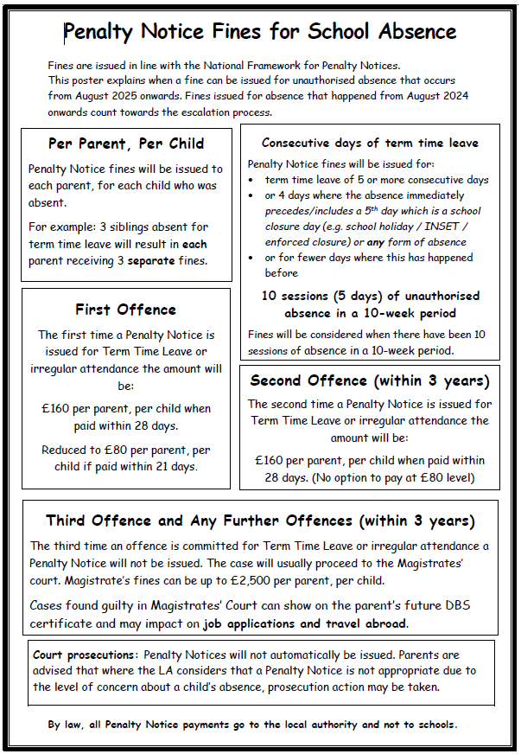

Penalty notices can be issued by a Headteacher, local authority officer or the police.
The decision on whether or not to issue a penalty notice may take into account:
- The number of unauthorised absences occurring within a rolling academic year
- One-off instances of irregular attendance, such as holidays taken in term time without permission
- Where an excluded pupil is found in a public place during school hours without a justifiable reason

If the payment has not been made after 28 days, the local authority can decide whether to prosecute or withdraw the notice.

Attendance monitoring
We monitor attendance daily in school. If your child’s attendance becomes a concern, you may have a phone call from one of the Pastoral team to see what support we can put in place to ensure your child/children are in school. Should absence continue, you may be invited into school for a meeting of concern where, alongside the Pastoral Team, you will complete an action plan with the aim of improving attendance.

Monitoring attendance
The school will:
- Monitor attendance and absence data half-termly, termly and yearly across the school and at an individual pupil level
- Identify whether or not there are particular groups of children whose absences may be a cause for concern

Pupil-level absence data will be collected each term and published at national and local authority level through the DfE's school absence national statistics releases. The underlying school-level absence data is published alongside the national statistics. The school will compare attendance data to the national average, and share this with the governing board. The school meet termly with other local schools to compare localised attendance data and trends- this will also be shared with the governing board.

Analysing attendance
The school will:
- Analyse attendance and absence data regularly to identify pupils or cohorts that need additional support with their attendance, and use this analysis to provide targeted support to these pupils and their families
- Look at historic and emerging patterns of attendance and absence, and then develop strategies to address these patterns

Using data to improve attendance
The school will:
- Provide regular attendance reports to class teachers, and other school leaders, to facilitate discussions with pupils and families
- Use data to monitor and evaluate the impact of any interventions put in place in order to modify them and inform future strategies

Reducing persistent and severe absence
Persistent absence is where a pupil misses 10% or more of school, and severe absence is where a pupil misses 50% or more of school.
The school will:
- Use attendance data to find patterns and trends of persistent and severe absence
- Hold regular meetings with the parents of pupils who the school (and/or local authority) considers to be vulnerable, or are persistently or severely absent, to discuss attendance and engagement at school
- Provide access to wider support services to remove the barriers to attendance

Monitoring arrangements
This policy will be reviewed as guidance from the local authority or DfE is updated, and as a minimum reviewed annually. At every review, the policy will be approved by the full governing board.

Links with other policies
This policy links to the following policies:
Child protection and safeguarding policy
Behaviour policy

